The graph below shows the top priorities by business companies in the USA in 2016.

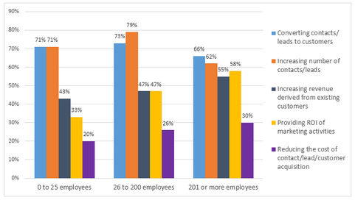

The graph provides information about percentage of the most popular business companies in the USA in 2016.

The overall number of priorities various for each type of firms. Mostly converting contacts and increasing number of contacts were the top priorities in all groups.

A more detailed look at the graph reveals that the highest position for all groups has 60 - 79 percentage. In the opposite side, for all groups the lowest number of priorities has reducing the cost of contact/lead/customer acquisition, which around only 25%. Furthermore, in the middle stage are increasing revenue derived from existing customers and providing ROI of marketing activities. In the group of 0 to 25 employees it has around 38%, in the group of 26 to 200 employees it has 47% and in the last group it is around 56%, which is the higher than in other two organizations.

Clearly, the converting contacts and increasing number of contacts are the most popular priorities by business companies in USA in 2016, while reducing the cost of contact/lead/customer acquisition has the lowest percentage for all firms.